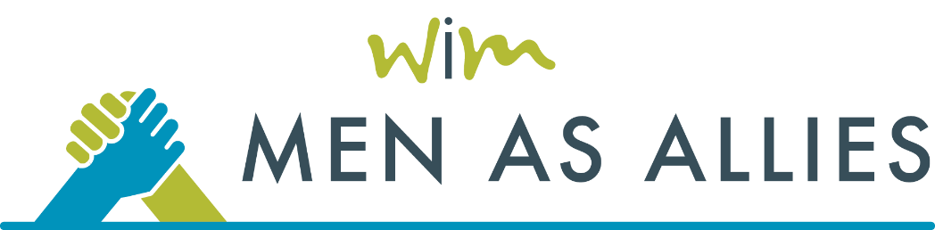

2026

MEDIA

TOOLKIT

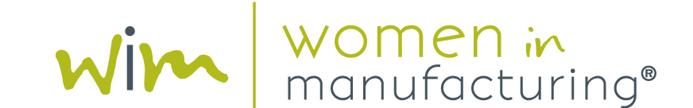
MEN AS ALLIES SPEAKERS, SPONSORS AND PARTNERS:
The 2026 Men as Allies Conference will take place in Clearwater, FL on February 18-19, 2026.

As a valued Men as Allies speaker, sponsor, or partner, we’re excited to provide you with marketing assets that you can share with your networks to help build awareness and engagement ahead of the conference.

CONFERENCE DESCRIPTION
Men as Allies is a two-day conference tailored for male leaders and managers in the manufacturing industry who want to leverage allyship to drive stronger team performance, improve employee engagement, and boost organizational results.
Over two days, participants will hear presentations and engage in discussions led by industry experts, offering practical insights and real-life examples to better support and advocate for women in the industry, driving meaningful and lasting change in their organizations.
Featured sessions and speakers for this year’s Men as Allies conference include:

- Opening Keynote
David Fernandes, Senior Vice President, Mazda Toyota Manufacturing, (MTM)

- Building Trust: The Key to Effective Allyship
Forrest Large, Owner - L2 - Learning & Development
- In Her Words: Women’s Perspectives on Support at Work
Moderated by: Allison Grealis, President & Founder, Women in Manufacturing (WiM)
Panelists:
Kate Leiby, GM Power Generation, Donaldson
Tiffany Bryson, Head of Industrial Partnerships, Blaser Swisslube
Michelle Mathis, Sr. Sales Operations Professional, Siemens

- Allyship in Action
Stacie Cassio, Founder & CEO, Pink Mentor Network, Inc.

- Working Better Together: Stories and Insights
Moderated by: Forrest Large, Owner - L2 - Learning & Development
Panelists:
Steve Speich, Sr. VP Product Technology, Engineering, Operations and Supply Chain, Winnebago Industries
Chris Porsch, National Sales Director, Blaser Swisslube

LINK
Web page: https://www.womeninmanufacturing.org/menasallies

SOCIAL HANDLES FOR WIM
LinkedIn @Women in Manufacturing
Facebook WomeninMfg
X @WomeninMFG

SAMPLE EMAIL FOR SPEAKERS, SPONSORS OR PARTNERS

<Your Greeting (Hi, Hello, etc.)> <First Name>,
I hope you will join <me/us> at Women in Manufacturing Association’s second annual Men as Allies Conference. This two-day event offers a dynamic platform to explore the influential role allies can play in strengthening teams, championing their workforce, and leading effectively in today’s evolving workplace. Through research-backed discussions and real-world examples, participants will gain valuable insights into allyship, engage in important conversations, and walk away with actionable strategies to create lasting, positive change in their organizations.

Event Details
- Date: Wednesday, February 18 – Thursday, February 19, 2026
- Location: Clearwater, FL

What to Expect at Men as Allies
- Insightful sessions and presentations that cover topics like the key to effective allyship, enhancing allyship through emotional intelligence, and putting allyship into action.
- Small group breakouts and panels tailored for open dialogue and practical learning.
- Network with others in the manufacturing industry who are committed to driving meaningful change and measuring its impact.
To view the complete agenda and register for the event, please visit https://www.womeninmanufacturing.org/menasallies

Don't miss this opportunity to be part of an important conversation shaping the future of manufacturing. Join <me/us> in Clearwater Beach and take the first step toward leading with purpose as an ally in your organization.

Warm regards,
[Your Name]

SAMPLE SOCIAL POSTS

Sample LinkedIn or Facebook Message
I'm excited to share a special event on my calendar! I will be attending the second annual #MenasAllies conference, happening February 18-19 in Clearwater, FL.

This is an opportunity to connect with leaders in the #manufacturing industry who are focused on driving measurable results through a stronger, more engaged workforce. Attendees will gain practical insights, tools, and strategies that directly enhance team collaboration, productivity, and overall business performance.

Don’t miss the chance to pick up insights and strategies that can boost your team’s performance and help your organization thrive. Learn more and register - https://www.womeninmanufacturing.org/menasallies

#WiMAllies #WomeninMFG

Sample X Message
Join me at the @WomeninMFG #MenasAllies conference on 2/18–2/19 to explore practical ways that allies can help build stronger, more inclusive teams in #manufacturing. https://www.womeninmanufacturing.org/menasallies

LOGOS AND GRAPHICS
