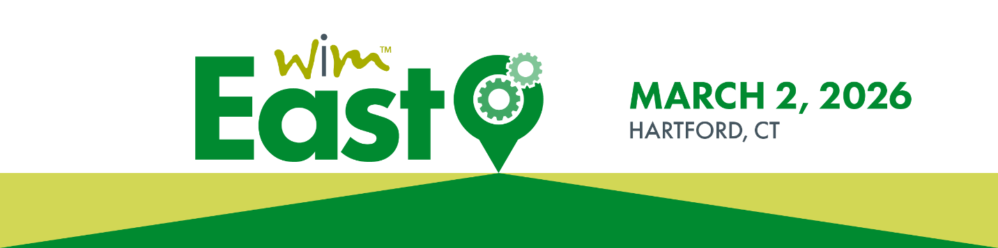

Marketing Toolkit

Thank you for helping us spread the word about this year’s WiM East event! This marketing toolkit will provide you with event assets and sample messaging that you can use to promote your participation in the conference. Within the toolkit, you will find:
- An event overview
- Sample personal email invitation
- Sample social media copy (LinkedIn, Facebook, Instagram and X)
- Event logos and graphics

You are welcome to modify the sample copy that we have provided to appeal to your specific audiences, but please remember to include the following:

Event hashtags: #WiMEast, #Manufacturing, #WomeninMFG
WiM’s LinkedIn: Women in Manufacturing
WiM’s Facebook handle: @Womeninmfg
WiM’s Instagram handle: @womeninmfg
WiM’s X handle: @WomeninMFG
Event/Registration Link: https://web.cvent.com/event/43f15542-14b1-4fba-960d-a392d8d4c284/summary

EVENT OVERVIEW

WiM East is a regional conference geared towards manufacturing professionals from production to executive level who are navigating their way through their careers. Hosted by the Women in Manufacturing Association (WiM), WiM East will take place in Hartford, CT on March 2, 2026.

WiM East offers participants unique and interactive opportunities that include:
- Gaining access to industry content shared by regional thought leaders.
- Engaging in professional and personal-based sessions that include timely topics that attendees can apply to their work and home life.
- Developing meaningful connections with peers in Connecticut, Pennsylvania, Massachusetts, Rhode Island, Virginia and more.

Any WiM East questions can be directed to Lizzy Lufkin at elufkin@womeninmfg.org

SAMPLE EMAIL

<Your Greeting (Hi, Hello, etc.)> <First Name>,

I would like to personally invite you and your colleagues to join <me/us> at the Women in Manufacturing Association’s (WiM) upcoming regional conference, WiM East, on March 2 in Hartford, CT. WiM East is an interactive learning and networking event designed to bring together manufacturing professionals based in Connecticut and surrounding eastern states for a day of inspiring presentations led by regional thought leaders, professional and personal learning sessions and opportunities to network with other peers from eastern manufacturing industries.

<I am/My company is> thrilled to be part of WiM East, and I hope you will join <me/us> for an impactful day of regional insights, networking and personal and professional development.

Kind regards,
<Your Name>

SAMPLE SOCIAL MEDIA POSTS

Sample LinkedIn, Facebook or Instagram Post
Join me at Women in Manufacturing’s #WiMEast regional conference on March 2 in Hartford, CT! This interactive learning and networking event is designed to bring together #manufacturing professionals from eastern U.S. manufacturing industries for a full day of learning and #networking. Visit the WiM East event page here: https://web.cvent.com/event/43f15542-14b1-4fba-960d-a392d8d4c284/summary
#WomeninMFG

Sample X Posts
Join me in supporting the success of current and future #manufacturing professionals by getting involved with @WomeninMFG’s #WiMEast regional conference! Learn more and register today: https://web.cvent.com/event/43f15542-14b1-4fba-960d-a392d8d4c284/summary #WomeninMFG

Are you a #manufacturing professional who is looking for personal and professional development opportunities in the industry? @WomeninMFG’s #WiMEast regional conference offers this and more. Learn more today: https://web.cvent.com/event/43f15542-14b1-4fba-960d-a392d8d4c284/summary #WomeninMFG

EVENT IMAGES
Click images to download.

Logo:
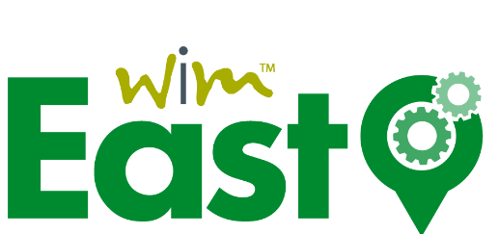

Banner:

Social:

